Open the TI-Nspire document Some_Like_It_Hot!.tns.

You may often hear of classrooms, schools, or towns having a certain amount of “diversity.” Used in this way, “diversity” refers to variety within a single species: OURS!

Even though students in your classroom, school, or town might seem to be really diverse on the surface, they are all human, just like you.

Outside of your school’s walls, there are lots of different species of organisms living with and among each other. Some are breathing the same air; some are using the same carbon dioxide; and some are competing for the same food, water, and space.

Even with all of this competition, species manage to survive. In fact, the health and stability of an environment depend on having a large variety of organisms living among one another. In this activity, you will examine some of the factors influencing the biodiversity of an ecosystem.

Move to Page 1.2 and read the background information for this activity.
Biotic factors (organisms) are impacted by the abiotic, or nonliving, factors in their environments. This is true for both terrestrial and aquatic environments. The abiotic factors in any environment have a huge impact on the biodiversity of that area. In general, the more "favorable" the abiotic conditions, the greater the biodiversity.

Move to pages 1.3 – 1.5. Answer questions 1-3 below and/or in the .tns file.
Q1. Give two examples of abiotic factors in an environment.

Q2. Which of the following does not belong?

- Snow
- Snow leopard
- Snow monkey
- Snowberry bush
Q3. The tropical rain forest would be expected to have a greater biodiversity than the Arctic tundra.

- Agree
- Disagree

Move to page 1.6.  2. On page 1.6, you will see a model of a lake ecosystem. Carefully read the directions that are covering the picture of the lake. When you understand what your task is, select and make the adjustments that the directions recommend. Pay close attention to what happens as the temperature and pH of the lake are changed. You will be asked about this later in the activity! | 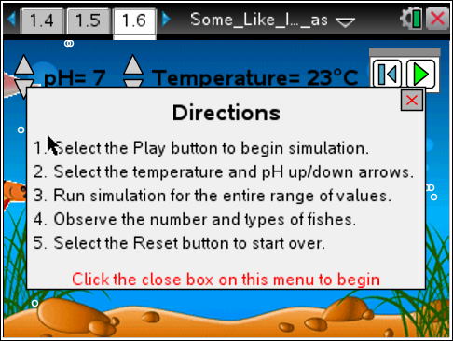
Tech Tip: To access the Directions again, select b or Document Tools () > Some Like it Hot > Directions.
Tech Tip: To access the Directions again, select > Some Like it Hot > Directions.
Move to pages 1.7 – 1.8. Answer questions 4 and 5 below and/or in your .tns file.
Q4. What are the variables that you can regulate in the simulation? (Select all that apply.)

- pH
- Population
- Species
- Temperature

Q5. Which of the following are "biotic" factors in the simulation? (Select all that apply.)

A. Fish
B. Gas bubbles
C. Plants
D. Water

Move to pages 1.9 and 1.10. Answer question 6 below and/or in your .tns file.
3. Read the content information about pH on page 1.9.

Q6. What do you think we call a solution that has a pH of exactly 7?

Move to pages 1.11 and 1.12.
4. On page 1.11, you will read about the meaning of biodiversity. After reading the information on this page, move to page 1.12. On this page, you will be instructed to return to the simulation on page 1.6 and review what happens when the pH and temperature of the water are changed.

Move to pages 1.13 – 1.17. Answer questions 7-11 below and/or in your .tns file.
Q7. How do temperature and pH affect each other?

- As temperature goes up, pH goes up.
- As temperature goes up, pH goes down.
- As temperature goes down, pH goes up.
- Temperature and pH do not affect each other.

Q8. In general, there is a greater diversity of fish when the water is warmer.

- Agree
- Disagree

Q9. As the water becomes more acidic, the diversity of fish decreases.

- True
- False

Q10. 20ºC is the same as about 68ºF. Your body temperature is about 98.6ºF. Predict what your body temperature is in ºC.

My body temperature is about _____ ºC.

Q11. Now go back to the simulation and change the temperature of the water so that it is the same as your body temperature. What do you observe?

Move to page 2.1 for the simulation on dissolved oxygen.  5. This next simulation deals with the relationship between water temperature and the levels of dissolved oxygen in the water. As in the first simulation, read the directions in the pop-up window. When you are ready to run the simulation, close the directions box by selecting . You will then vary the water temperature and collect data on dissolved oxygen levels. | 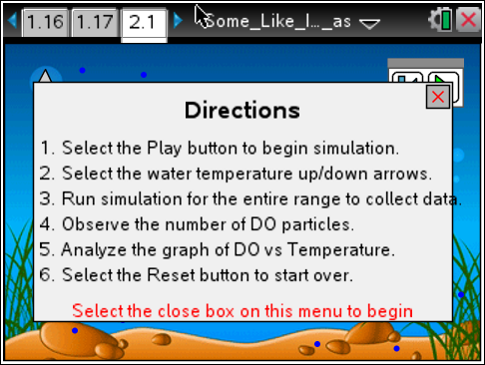
Move to pages 2.2 – 2.8. Answer questions 12-18 below and/or in your .tns file..
Q12. What happened to the amount of dissolved oxygen as you increased the temperature of the water?

Q13. What happened to the amount of dissolved oxygen as you decreased the temperature of the water?

Q14. Which term do you think best describes the relationship between water temperature and dissolved oxygen levels?

- Direct B. Inverse

Q15. Fish such as salmon and trout need a lot of oxygen to survive. Which water temperature do you think would be best for these fish?

- 40ºC
- 30ºC
- 20ºC
- 10ºC

Q16. In which of the following environments would you expect to find the most salmon and trout?

- in warm, coastal ocean waters
- in mountain rivers and streams
- in lakes in the southern United States
Q17. Catfish have a lower oxygen requirement than many freshwater fish. In which state do you think catfish would thrive?

- Alabama
- New York
- Montana
- Alaska

Q18. Why do you think it would be difficult to have salmon and catfish together in the same aquarium?

Move to page 2.9.
6. On page 2.9, there is a graph of the data that was collected automatically as you made changes to the water temperature in the simulation. Plot the data below as it appears in the graph on your .tns file.

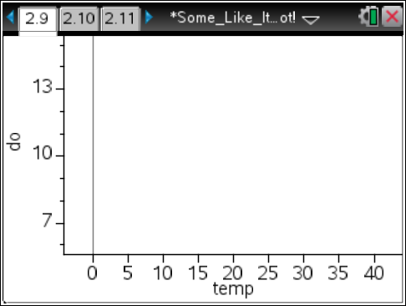

Tech Tip: To modify the scale of the x and y-axes, place two fingers on the screen and then drag your fingers away from each other or towards each other parallel to the axis.
Move to pages 2.10 – 2.11. Answer questions 19 and 20 below and/or in your .tns file.
Q19. Which words could be placed in the blanks below to make the statement true? (Select all that apply).

As water temperature goes _____, the dissolved oxygen level goes _____.

- up; up
- up; down
- down; up
- down; down

Q20. Predict what would happen if the water continued to get warmer and warmer.

- The dissolved oxygen levels would continue to drop.
- The dissolved oxygen levels would eventually start to increase.
- The dissolved oxygen levels would eventually be less than zero: negative values.

Move to page 2.12.
7. The final page of the activity shows you the actual data that was collected as you made changes to the temperature of the water in the dissolved oxygen simulation.

