- Open the TI-Nspire document Solving_Systems_by_the_Elimination_Method_.tns.  This activity shows you how to create an equivalent system of equations from a given system of equations. A carefully created equivalent system of equations simplifies the solution process. Click on the Δ or ∇ symbol on the screen to change the values of the multipliers a and b. | 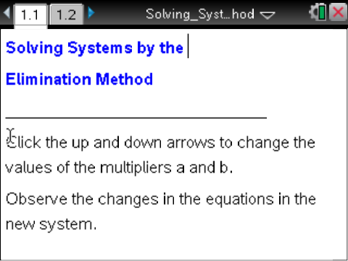

Move to page 1.2. | Press / ► and / ◄ to navigate through the lesson.
1. Use the up or down symbols on the screen (Δ or ∇) to change the values of a and b. How do the values of a and b determine the new system?

2. How is the equation in the box related to the equations above it?

3. Change the multipliers a and b until the coefficient of x in the boxed equation is zero. Record your multipliers: a =________, b = ________

a. What must be true about the coefficients of x in the new system for their sum to be zero?

b. How are the new coefficients related to the coefficients in the original system?

c. Use the boxed equation to solve for y, and record your answer.

d. What is the solution to the system of equations? How do you know?

4. Change the multipliers a and b to find different values that still produce a zero coefficient of x in the boxed equation. Record your multipliers: a =________, b = ________

a. How are the new coefficients related to the coefficients in the original system?

b. Use the new boxed equation to solve for y, and record your answer. What do you observe about this solution compared to the one you found in problem 3c?

5. Now change the multipliers a and b until the coefficient of y in the boxed equation is zero.

a. What do you observe about the coefficients of y in the new system?

b. Use the boxed equation to solve for x, and record your answer.

c. What is the solution to the system of equations, and how do you know?

d. How does this compare to your solutions in Problems 3 and 4? Explain why.

6. Is it possible to eliminate one variable by producing a coefficient of zero for x in any system of equations? Justify your answer.

Based on what you have learned, complete the following problems with pencil and paper.

7. Sarah was solving the system: –x + 4y = 8
3x + 2y = 18
She found x = 4. What should she do next, if anything?

8. Given the system: 3x + y = 7
5x – 2y = 8
a. Show how you would eliminate x.

b. Show how you would eliminate y.

c. What is the solution to the system?

