Open the TI-Nspire document Exponential_Functions.tns.  What is true of the function values f(x) = ab^{x} when a > 0? Or when a < 0? What is true about the graph of f(x) = ab^{x} when b > 1? Or when 0 < b < 1? In this activity, you will explore these topics as you investigate the effects of a and b on the graphs of functions of the form f(x) = ab^{x}. | 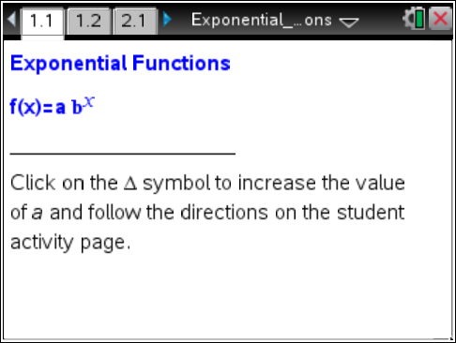

Move to page 1.2.

1. On page 1.2, you will see a graph of the function f(x) = ab^{x}, where a = 1 and b = 2. Click on the Δ symbol to increase the value of a.
a. What happens to the graph of f(x) = ab^{x} as you increase the value of a?

b. Does the domain change?

c. Does the range change?

2. Click on the ∇ symbol to change the value of a to a negative number.
a. What happens to the graph of f(x) = ab^{x}?

b. Does the domain change?

c. Does the range change?

3. For the function f(x) = ab^{x}, find the following values.
a. f(0)

b. y-intercept of the graph

4. Describe the graph of f(x) = ab^{x} when a = 0. Why does this happen?

5. A function is called exponential if it is of the form f(x) = ab^{x}, provided a ≠ 0, b > 0, and b ≠ 1.
a. Why do you think that a = 0 is not included?

b. Why is the base b = 1 not included?
Move to page 2.1.

6. On page 2.1, you see a graph of the function f(x) = ab^{x}, where a = 1 and b = 1/2. Click on the Δ symbol to increase the value of a.
a. What happens to the graph of f(x) = ab^{x} as you increase the value of a?

b. Do the domain and range change? Explain.

7. Click on the ∇ symbol to change the value of a to a negative number.
a. What happens to the graph of f(x) = ab^{x}?

b. Does the domain change?

c. Does the range change?

8. Look at the graph at the right of f(x) = ab^{x}. Margaret says that a < 0 and b > 1. Is she correct? Justify your response mathematically.

Move to page 3.1.

9. Sketch the graph of each of the following.

Graph: f(x) = ab^{x} | a > 0 | a < 0
When b > 1
When b = 1
When 0 < b < 1

