Open the TI-Nspire document Center_of_Mass.tns.  In this activity, you will investigate Center of Mass with a simulation of balance. | 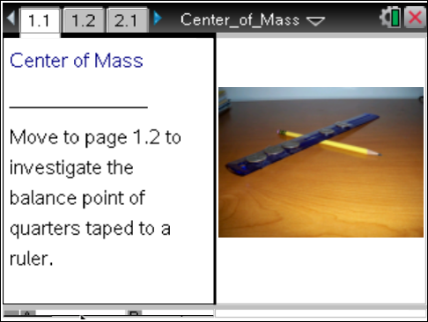

Move to page 1.2.

Five quarters are taped at various locations along a lightweight 12-inch ruler. A pencil is placed under and perpendicular to the ruler. The pencil is carefully moved along the bottom side of the ruler to find a location that balances the quarters on the ruler.

1. On the graphic representation on Page 1.2, the blue points represent the location of the 5 quarters along a 12-inch ruler. Identify the location of the quarters.
  - Quarter 1 is at ______ inch.

  - Quarter 2 is at ______ inches.

  - Quarter 3 is at ______ inches.

  - Quarter 4 is at ______ inches.

  - Quarter 5 is at ______ inches.

2. The position of a fulcrum is represented by the symbol “Δ.” The pencil serves as the fulcrum in this problem because it supports the ruler and the quarters. Note on Page 1.2 that a vertical line is drawn to represent the location of the fulcrum.
a. What is the location of the fulcrum along the bottom of the ruler?

b. Does this location of the fulcrum balance the quarters? Explain your answer.

c. How do you think the ruler would look if the pencil balanced the quarters?

How is balance achieved? The first step is to consider a physics concept, a moment arm. The force of gravity pulls each quarter downward. The pull of the quarters on one side of the fulcrum must equal the pull on the other side for the position of the fulcrum to balance the quarters. The pull that a quarter provides, called the “torque” or the “moment” (M), is a product of the force (F) or weight of the quarter times the distance (d) of the quarter from the fulcrum. This description is summarized mathematically as: M = F × d.

3. Let the force or weight of a quarter be represented by F. Consider the quarter located at position 3 inches on the ruler with the fulcrum located at 7 inches. The moment that this quarter exerts would be represented as 4 × F, or 4F since the quarter is a distance of 4 units from the fulcrum.
a. What is the sum of the moments exerted by the quarters to the right of the fulcrum?

b. What is the sum of the moments exerted by the quarters to the left of the fulcrum?

c. Explain why the ruler would or would not balance if the fulcrum were located along the bottom of the ruler at 7 inches.

4. a. What is the sum of the distances of the quarters located on each side of the fulcrum?

b. Make a conjecture about what you think happens to the sum of the distances as the fulcrum is moved left to a position that will balance the quarters. Make a sketch of the ruler and fulcrum to illustrate your conjecture.

5. To test your conjecture in 4b, grab the point on the bottom of the ruler representing the position of the fulcrum and move it to the left.
a. What happens to the sum of the distances on the right and the sum of the distances on the left as you move the fulcrum to the left?

b. Move the fulcrum until it appears balanced. Describe the picture in terms of the ruler.

c. Consider the position of the fulcrum when the ruler is horizontal. What is the sum of the distances on each side of the fulcrum?

d. Explain how the position of the fulcrum that balances the quarters confirms or does not confirm your conjecture in question 4b.

6. Many different summary statistics can characterize a data set. Some common summary statistics are the minimum, the maximum, mean, median, and range. Each of these statistics is valuable in and measures a specific characteristic of the data set. Determine the minimum, maximum, mean, median, and range of the locations of the quarters on the ruler. Do any of these summaries support your conjecture about the balance point? Explain your answer.

Move to pages 2.1 and 2.2.

- The five quarters on the ruler are rearranged Page 2.2. Identify the location of each quarter.
- Quarter 1 is at ______ inch.

- Quarter 2 is at ______ inches.

- Quarter 3 is at ______ inches.

- Quarter 4 is at ______ inches.

- Quarter 5 is at ______ inches.

8. Move the fulcrum to the 7-inch mark.
a. Let X equal the distance of the quarters from the fulcrum to the 10-inch mark. The sum of the distances to the right of the fulcrum would be equal to the following:
2X + 5. Determine the value of the X. Why is the value represented by the X multiplied by 2?

b. What is the sum of the distances to the right of the fulcrum?

c. What is the sum of the distances to the left of the fulcrum?

d. Calculate the sum of the distances if you were to tape another quarter at location10.

9. Move the fulcrum to a point that will approximately balance the quarters.
a. How do you know you have found the balance point? What is the estimate of this position?

b. Is the location of the balance point the same as the location suggested by the numerical calculations? Explain.

10. a. What other factors do you think might also affect the location of the balance point?

b. Why might the balance point be called the weighted mean in this second problem?

