Open the TI-Nspire™ document Domain_and_Range_of_Exponential_Functions.tns.  Consider the function f(x) = 2^{x}. What values can you use for x? What are possible output values for the function? How would input and output values be different if the base is changed to ? In this activity, you will explore the domain and range of exponential functions. | 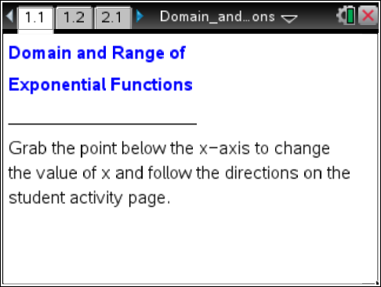

Move to page 1.2.

1. a. How do the values of the function f(x) = 2^{x} change as the value of x increases? Use the function rule f(x) = 2^{x} to explain your answer.

b. How do the values of the function f(x) = 2^{x} change as the value of x decreases?

c. If x is a negative number, is the value of 2^{x} also negative? Explain why or why not.

2. Not all function values are being calculated for you because the document was created to display only values for x that are integers. Use the graph to help you estimate what value for x produces a value of 2^{x} = 6.

x =

Move to page 2.1.
3. Use page 2.1 to support your response to question 2 or to revise your estimate.

4. a. What is the set of all values of x (the domain) that can be used as inputs in f(x) = 2^{x}?

b. What is the set of all outputs (the range) of f(x) = 2^{x}?

Move to page 3.1.

5. a. How does the value of the function f(x) = change as the value of x increases? Use the function rule f(x) = to explain your answer.

b. How does the value of the function f(x) = change as the value of x decreases?

6. a. What is the domain of the function f(x) = ?

b. What is the range of the function f(x) = ?

7. Compare the graphs of f(x) = and f(x) = 2^{x}.
a. What do these two graphs have in common?

b. What is different about the two graphs?

8. a. Would the graph of f(x) = look more like the graph of f(x) = or the graph of f(x) = 2^{x}? Why do you think so?

b. What is the domain of f(x) = ? What is the range of f(x) = ? Explain.

