This activity gives students an opportunity to explore the definition of a function graphically, with a set of ordered pairs, and by using equations to apply function models to real world situations. These models dynamically allow students to discover the function by experimenting with input values that produce the desired output. Function notation will also be reinforced. | 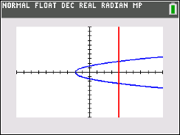

Definition
A function is a relation in which each input is paired with exactly one output.
For every value that goes into a function, the function outputs one unique result.

Problem 1 – Graphical
At time t = 0, Marty is at position d = 2.
1. Discuss with a classmate if the graph to the right describe Marty’s position as a function of time. Explain.

2. Describe what would have to happen for this graph to occur.
3. Redraw the dashed lines to make the graph a function. Share your graph with a classmate and discuss any differences.

Problem 2 – Set of ordered pairs
The first element of each ordered pair is the input value.
4. Discuss with a classmate which sets below describe a function. Explain why.
A. {(0, 1), (1, 4), (2, 7), (3, 6)} B. {(−2,2), (−1, 1), (0, 0), (1, 3), (2, 4)}
C. {(3, 2), (3, 4), (5, 6), (7, 8)} D. {(2, 3), (3, 2), (1, 4), (4, 1)}

Marty flies to Mars, where the acceleration of gravity is 0.375 of what it is on Earth. So with a = 12 ft/s², use the distance formula to compute the output when given the input for questions 5 through 8.

5. Use the formula to compute d. Give the set or ordered pairs (t, d) when the input t is the set {0, 1, 2, 6}.

6. Use the formula to compute t. Give the set of ordered pairs (d, t) if the input is d. The input set for d is .

7. Discuss with a classmate which of the two solutions sets from Questions 5 and 6 is a function. Explain why.

8. From solutions sets above, discuss with a classmate and explain which is true.
A. d is a function of t B. t is a function of d
C. both D. neither

Problem 3 – Function notation
If f is a function of x this can be written as f(x).  For example, f(x) = x². So f(3) = 9.  To use the function ability of your graphing calculator, press y = and enter x² – 2x + 3. |  | 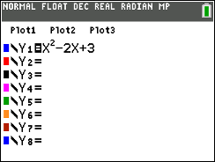
Return to the Home screen.  To enter different values for x and observe what f(x) equals, press vars, arrow right to the Y-VARS menu, select Function and then choose Y1. Then enter (#), replacing # with the x-value.  Press up arrow twice and then enter to recall the last entry. |  | 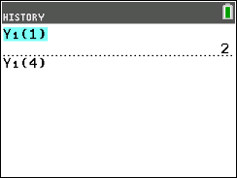
9. For f(x) = x² – 2x + 3, find f(4) using the graphing calculator, then by substitution showing your work below.

10. For f(x) = 3x² + 5x + 3, find f(2) using the graphing calculator, then by substitution showing your work below.

Problem 4 – Find the Function
11. Given the input 17 for the function f(x) that gives an output of 8.5, find two possible functions for f(x). Discuss with a classmate how you found them and share with the class.  (For example, f(x) = x² – 16.5x will give an output of 8.5 for an input of 17. Be as simple or complex as you like with your functions!) |  | 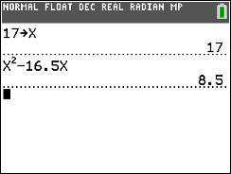
12. Given the input -4 for the function f(x) that gives an output of 6, find two possible functions for f(x). Discuss with a classmate how you found them and share with the class. |  | 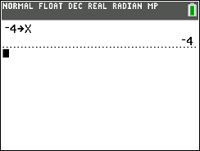
13. Given the input 20 for the function f(x) that gives an output of 83, find two possible functions for f(x). Discuss with a classmate how you found them and share with the class. |  | 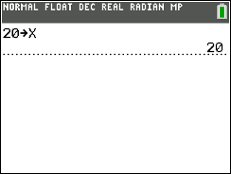

Further IB Application

In a longest throw competition, the height of a football thrown down field by a quarterback to a target down field is modelled by the function:

Where h(t) is the height of the ball in meters above the ground at the instant it is thrown by the quarterback.

(a) Write down the height of the ball above the ground the instant it leaves the quarterback’s hand.

(b) Find the value of t when the ball hits the ground.

(c) State an appropriate domain for t in this model.

