Open the TI-Nspire document Concavity_CAS.tns.  Objective: To determine a relationship between the first and second derivative and the graph of a function.  Directions: Grab and move the point on the graph and note the description at the bottom of the page to answer the questions. | 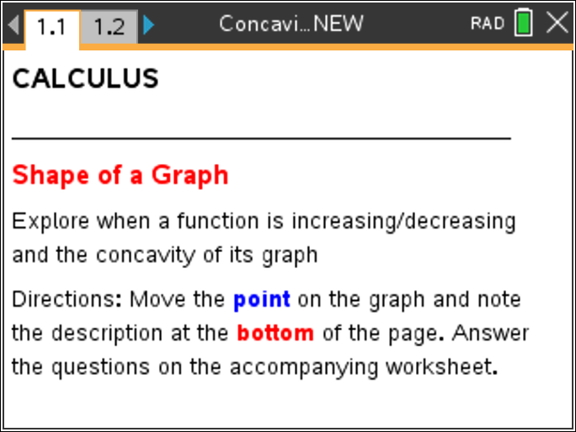

Move to page 1.2. | Press / ¢ and / ¡ to navigate through the lesson.
PART I:
Move the point on the graph and record a point on the function that meets each of the following criteria:

Criteria | Point
Increasing, Concave Up

Increasing, Concave Down

Decreasing, Concave Up

Max or Min, Concave Up or Down
(2 points)

1. Compare your points with another classmate’s. Work together to determine if you can find the range of x-values where the function is:

a. Concave Up

b. Concave Down

c. Increasing

d. Decreasing
PART II:
Directions: Turn on the Geometry Trace: Menu > Trace > Graph Trace. Press ? to find the letters that will help you find the following parts of the graph.
2. Record the points below, then describe what the graph is doing using increasing, decreasing, concave up, and concave down at the point and immediately to the left and right of the point.
a. Maximum

b. Minimum

c. Point of Inflection

3. Based on your observations, describe how the sign of the derivative helps you determine when function has a:
a. Maximum

b. Minimum

c. Point of Inflection

Extension:
Use Scratchpad to graph the function. Using this graph, determine where/if the anti-derivative function will have a maximum, minimum, or point of inflection.

