This activity gives students an opportunity to see where large and small numbers are used and how scientific notation offers a convenient method of writing such numbers. This will be done both with and without technology. | 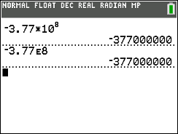

Part 1 – Writing Scientific Notation in Expanded Form
Scientific notation is a way of writing very large and very small numbers. Numbers in scientific notation include two parts, a number greater than or equal to 1 and less than 10, and a power of 10. Examples include:
5.6×10⁵ = 5,600,000 and 2.3×10⁻⁸ = 0.000000023
Write each of the following numbers in expanded notation. Check your answer with a calculator.
1. –3.77×10⁸  Write the answer. |  | 3. 4.224×10⁻⁶  Write the answer.
2. 1.202×10⁵.  Write the answer. |  | 4. –5.24×10⁻¹²  Write the answer.
Part 2 – Writing Numbers in Scientific Notation
To write numbers in scientific notation, place a decimal point so there is one non-zero digit to the left. Count the number of decimal places the decimal point moved. The number of places the decimal point moves to the left is the positive exponent power of 10. The number of places the decimal point moves to the right is the negative exponent power of 10.
For example: 156,000,000 = 1.56×10⁸ and 0.0000045 = 4.5×10⁻⁶

5. The following are salaries for the 5 top paid players of the Cincinnati Bengals. Write each salary in scientific notation.
Player | Salary | Scientific Notation
Joe Burrow | $19,515,043
DJ Reader | $15,521,324
Trey Hendrickson | $15,143,126
Jonah Williams | $12,604,000
BJ Hill | $10,354,000

6. The 2022 median American household income was $7.4580 × 10⁴. Compare this to the salaries above. Explain what you notice.

7. Imagine you could fold a piece of paper 0.004 inches thick 50 times. Find how many inches thick the resulting paper would be after the 50th fold.  To solve, type 0.004 on the home screen and press e. Then, type * 2 e. Each time e is pressed, the previous value is doubled. |  |  | 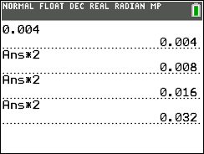
8. Write this answer in expanded form.
9. Find the probability of flipping a coin 40 times and having it come up heads each time.  To solve, type 0.5 on the home screen and press e. Then, press * 0 . 5 e. Each time e is pressed, the previous value is multiplied by 0.5. The screen at the right shows the probability of heads once, two times in a row, three times in a row and four times in a row. |  |  | 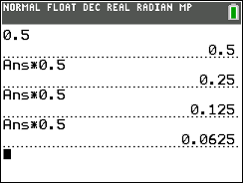
10. Write this answer in expanded form.

Part 3 – Ordering Numbers in Scientific Notation
11. Place the following numbers on the number line. After placing them on the number line, switch with a partner to check answers.
a. 1.25×10⁻³  b. 5.5×10⁴ | c. –4.45×10⁴  d. –3.11×10⁶ |  |  | e. 1.8×10²  f. 7.79×10⁸
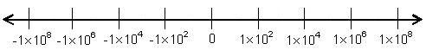
12. Draw an appropriate number line for the following numbers. Explain your choice.
2.25×10⁻³ | –1.05×10⁻⁴ |  |  | 5.603×10⁻²
Part 4 – Operations with Scientific Notation
Numbers that are written in scientific notation can be multiplied and divided rather simply by taking advantage of the properties of numbers and the rules of exponents that you may recall. To multiply numbers in scientific notation, first multiply the numbers that are not powers of 10 (the a in a x 10^{n}). Then multiply the powers of ten by adding the exponents.
In order to divide numbers in scientific notation, you once again apply the properties of numbers and the rules of exponents. You begin by dividing the numbers that are not powers of 10 (the a in a x 10^{n}). Then you divide the powers of ten by subtracting the exponents.

13. Perform the indicated operation for each problem and write in the form a × 10^{n}, where
1 ≤ a < 10, and n ϵ ℤ:
____________________________

____________________________

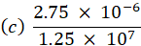 ____________________________

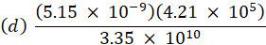 ____________________________

Further IB Application

The asteroid belt orbiting around the sun between Mars and Jupiter is said to be valued at over $715 quintillion dollars (US), where one quintillion = 10¹⁸. This equates to each person on the planet earth having approximately 100 billion dollars (US).

(a) Write down the value of the asteroid belt in the form a × 10^{k} where 1 ≤ a < 10, k ϵ ℤ.

One of the asteroids in the belt is named Diotima and is approximately spherical with a diameter of 176 km.

(b) If you were to use this information to estimate its volume, calculate its volume in
km³.

(c) The actual volume is found to be 2.95 × 10⁶ km³. Find the percentage error in your
estimate of the volume.

