Open the TI-Nspire document Dynagraph.tns.  In this activity, you will drag a point on a function representation, called a dynagraph, to discover various relationships between the function's input and output. | 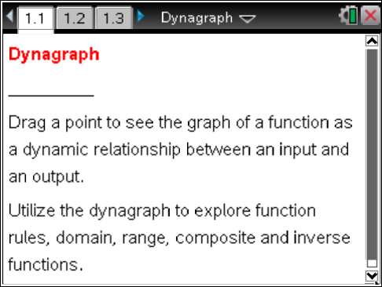

A dynagraph is a dynamic mapping that relates a number in one set (the domain) to a number in a second set (the range). While a coordinate system uses a coordinate point as (input, output), a dynagraph uses a line segment with endpoints as input and output. The function rule that maps an element in the domain to its corresponding element in the range is indicated by an arrow.

Move to page 1.3.

1. The dynagraph in the left work area represents an unknown function. As you drag the open point at the base of the arrow, notice that the x and f(x) values change, and the corresponding coordinate point, (x, y), is graphed on the Cartesian plane on the right.
a. Use the table below to record the input and output values that you obtained.
x
y = f(x)

b. Find the “mystery rule” for f(x) that pairs each value for x with a value for y. Enter your equation into f1 on the right side of the page. Test your prediction by using the dynagraph. Each point should lie on the graph of your function. Write the equation for the “mystery rule.”
Tech Tip: Press / e to access the graph in the right work area. Press / G to display the function entry line.
Tech Tip: Double tapping within the right work area will display the function entry line. If students wish to edit a previous entry, they can double tap the right work area again and press the up arrow to access the f1(x) equation.

c. What are the domain and the range of your function?

Move to page 2.2.

2. The dynagraph on this page follows a non-linear function rule. As you drag the open point, you’ll notice that the arrow disappears.
a. Why does the arrow disappear? When does this happen?

b. Use the table below to record the input and output values that you obtained.
x
y = f(x)

c. Find the “mystery rule” for f(x) that pairs each value for x with a value for y. Enter your equation in f1. After you’ve tested your prediction, write the equation for the “mystery rule.”

d. What are the domain and the range of this function?

Move to page 3.2.

3. This dynagraph consists of three vertical number lines and behaves like two function machines wired in series. The point at x identifies a domain value on the first number line and is dynamically linked by the function f(x) to a range value on the middle number line. That value is then linked by a second function g(x) to a value g(f(x)) on the far right number line. For example, the number 5 is linked to 9 by f(x) (because f(5) = 9), which in turn is linked to 12 by g(x) (because g(9) = 12). Grab and drag the base of the arrow at point x. Set x = 5, and confirm that f(5) = 9 and g(9) = 12.

a. Use the table below to record the input and output values that you obtained.
x | 5
f(x) | 9
g(f(x)) | 12

b. Find the rule for f1(x) = f(x) that pairs each value for x with a value for f(x). Find the rule for f2(x) = g(x) that pairs each value for x with a value for f2(f1(x)) = g(f(x)). Enter your equations into f1(x) and f2(x) Test your predictions by using the dynagraph. Each point should lie on the graph of your function. Write the equations for the “mystery rules.”

c. Find a rule for the single function f3(x) that gives the same result as f2(f1(x)) for all values of x. Enter your equation into f3(x). Test your prediction. Write the equation for this composite function.

d. Compute and compare the following. You may want to use a calculator page to perform the computations.
Tech Tip: Calculate using the Scratchpad »
Tech Tip: To add a calculator page, select  > Calculator
i. f2(f1(4))
ii. f1(f2(4))
Try other values of x. Does the order in which you apply the functions matter? Why do you think that this is true?

e. Give an example of two functions, f(x) and g(x), with neither function in the form y = x, such that g(f(x)) = f(g(x)).

Move to page 4.2.

4. The “inverse” of a function f, denoted f ^{–1}, “undoes” the function—it maps a point y from the range back to its original x from the domain. You can think of a function and its inverse as a special case of function composition.

By definition, g(x) is the inverse if and only if g(f(x)) = x for every x in the domain of f(x), and
f(g(x)) = x for every x in the domain of f(x). In the context of the dynagraph, f2 is the inverse of f1 if f2(f1(x)) horizontally aligns with x for all values in the domain of f1 (i.e. f2(f1(x)) = x), and vice versa.

a. The dynagraph on Page 4.2 shows the composite function g(f(x)). As you drag the open point, notice that g(f(x)) = x for all input values of x.
Navigate to the right work area, and notice that f1(x) = –2x + 4 and f2(x) = x. Find the rule for f2, the inverse of f1. Enter your equation into f2(x). Test your prediction by using the dynagraph, and write the equation for f2.
b. Evaluate f2(f1(x)) and f1(f2(x)).

Move to page 5.2.

5. a. Given the functions and g(x) = x², evaluate f(g(x)) and g(f(x)). Are the functions inverses? Explain your answer.

b. On Page 5.2, grab and drag the base of the arrow at point x. What happens when x < 0? Why does this happen?

c. Navigate to the right work area, and notice that and f2(x) = x². Find the rule for f2, the inverse of f1. Enter your equation into f2(x). Test your prediction by using the dynagraph, and write the equation for f2.

d. What are the domain and range of f1(x) and f2(x)?

