Open the TI-Nspire document Triangle_Trigonometry_and_ Circles.tns.  Why is the tangent of an angle always the same, no matter the size of the triangle containing the angle? In this activity, you will explore the reasons for this and learn why knowing the trigonometric functions of one angle makes it easy to find the trigonometric functions of at least three more angles. | 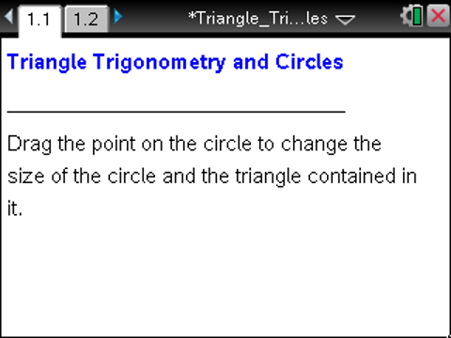

Move to page 1.2. | Press / ¢ and / ¡ to navigate through the lesson.
1. The angle in the right triangle which is adjacent to its horizontal leg (opposite its vertical leg) is fixed. You can drag the point on the circle to change the radius of the circle, and, therefore, the hypotenuse of the triangle. The length of the radius and the coordinates of the point are shown.
a. Set the radius to 3. You can do this by clicking directly on the measurement for the radius and typing in 3. What are the lengths of all three sides of the triangle? How do you know?

b. Predict what will happen to the lengths of the horizontal and vertical legs of the triangle if you drag the point on the circle to change the radius. Why do you predict this?

c. Test your prediction in part b. What happens to the side lengths of the triangle? Why?

2. Set the radius to 3 again. The ratios of the side lengths appear on the left side of the screen.
a. Predict what will happen to each ratio as r increases and decreases. Why do you predict this?

b. Test your prediction in part a. What happens to the ratios as r changes? Why?

3. Each of the ratios on the left side of the screen is the value of a trigonometric function for the angle θ—the interior angle of the triangle formed by the hypotenuse and the horizontal leg.
a. Rewrite each ratio on the left side of the screen as a trigonometric function of θ. How did you determine these?

b. Based on your responses to question 2, what will happen to the trigonometric functions of θ as the side lengths of the triangle change, but the angle stays fixed? Why?

c. Use a geometric argument to explain why tan θ will always be the same if θ is the same, no matter how large the sides of the triangle in which θ is contained.

d. Does the same argument from part c hold for the other trigonometric functions? Explain.

4. a. What happens to the triangle if you drag the point around the circle? What other triangles are possible?

b. Why are these the possible triangles?

c. What do all these triangles have in common?

5. An angle formed by the x-axis and a segment or ray in the coordinate plane is measured counter-clockwise from the x-axis. Move the point on the circle so the triangle appears in the second quadrant. Consider the angle from the x-axis counter-clockwise to the hypotenuse of the triangle, marked β in the figure below.
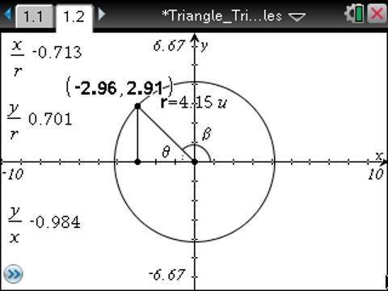
a. The acute angle between the x-axis and the ray or segment in the coordinate plane is called the reference angle. θ is the reference angle for β. What is the relationship between θ and β? Express β in terms of θ if both are measured in radians. Express β in terms of θ if both are measured in degrees. Fill in the table below.

 | β in quadrant I | β in quadrant II | β in quadrant III | β in quadrant IV
Degrees
Radians

b. How can you use the ratios displayed to find tan β, sin β, and cos β? Explain.

6. a. What will happen to the three ratios if the triangle is in the third quadrant? The fourth quadrant? Explain.

b. Move the point on the circle to test your predictions in part a. How do the results compare to your predictions?

7. Write an algorithm (a set of steps) explaining how to find sin β, cos β, and tan β based on the reference angle θ. Your algorithm should address all possible locations of β and the differences (if any) when β is measured in radians or degrees.

