Open the TI-Nspire document DoesACorrelationExist.tns.  In this activity you will create graphs from lists of data and determine if the data sets have a positive or negative correlation coefficient. You will also determine the linear regression for each data set and calculate the correlation coefficients. You will then use the linear regression to predict the values of unknown data points. | 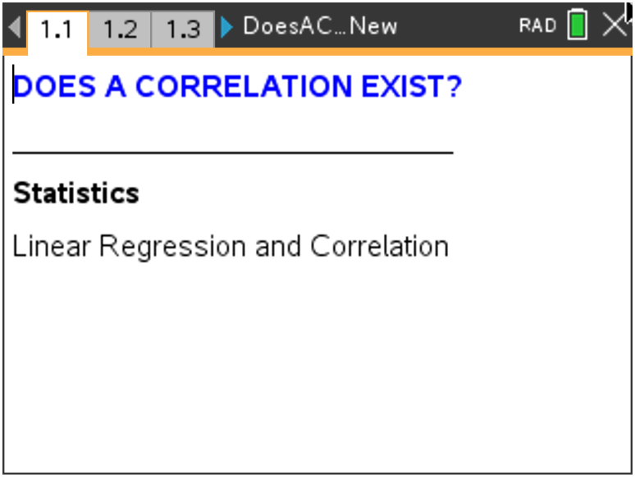

Problem 1 – Home Price and Square Footage

In this problem, you will examine how the selling price of a house is related to the square footage of the house. In the spreadsheet on page 1.2, two columns of data are given. One lists the selling price of houses (given in hundreds of dollars) and the second lists the square footage of the house.
- Describe how you think the selling price of a house relates to the amount of area of the house or square footage. State if there is any correlation. State which variable is the independent variable. State which is the dependent variable. Explain. Discuss what else the price of a house might depend upon.

On page 1.3, create the scatter plot.
2. Explain the meaning of the point (2650, 2050). Include units.

3. Choose the type of correlation (one from each row).
Positive Negative
Very strong Moderately strong Moderately weak Very weak
4. Predict the value of the correlation coefficient to one or two decimals. Explain your reasoning.

Calculate the correlation coefficient and the linear regression equation on page 1.4. Select MENU > Statistics > Stat Calculations > Linear Regression (mx+b). In the dialog box, choose your independent variable for the X list and your dependent variable for the Y list. Save your regression equation to f1. (This should be in the box already.) Ignore the other boxes.
5. Find the correlation coefficient, r. Describe how the coefficient compares with your description of the
correlation. Explain how your prediction compares.

6. Write down the regression equation.

Return to the scatter plot on page 1.3 and graph the regression equation. Select MENU > Analyze > Regression > Show Linear (mx+b). The line and its equation will appear.
7. State the sign of the slope. Explain how this relates to the sign of the correlation coefficient. Describe
the meaning of the slope in the context of the data. Also explain the y-intercept in the context of the
data.

Use the regression equation to solve the following.
8. Predict the price of a house that has 3,500 square feet.

9. Predict the number of square feet for a house costing $150,000.

10. Predict the price of a house with 50,000 sq. ft. State if this prediction seems reasonable based on the
data given. Explain.

11. Predict the number of square feet for a house costing $5.2 million. State if this prediction seems
reasonable based on the given data. Explain.

Problem 2 – S.A.T. Verbal and Math Scores
On page 2.1, the spreadsheet contains two columns of data. One lists the Verbal scores and the second lists the Math scores from male and female students who took the SAT exam.
12. State if you think the students who score well on the Verbal section of the SAT exam also score well on the Math section. Discuss and record your thoughts on which variable is the independent and dependent variable. State if you think there will be a correlation.

13. Create the scatter plot on page 2.2. Choose the type of correlation (circle your answer).
- positive negative
State if you think the correlation is stronger, weaker, or about the same as the data set from Problem
1.

On page 2.3, find the linear regression equation the same way you did in Problem 1.
14. State the correlation coefficient.

15. Record the regression equation and explain the meaning of the slope.
Return to the scatter plot and graph the regression equation. Use the regression equation to answer the following questions.
16. Predict the Math score if the Verbal score is 500.

17. Predict the Verbal score if the Math score is 620.

18. State if there is a relationship between these two variables. State if one is dependent on the other.
State if an increase in one means an increase in the other. In other words, while there is correlation,
discuss if there is causation.

Problem 3 – Latitudes and Temperatures in January
On page 3.1, the data set is the latitude in degrees north of the equator and the average minimum January temperature in °F (1931–1960).

19. State if you think the latitude of a location is related to the temperature at that location. Discuss and
record you thoughts. State the independent and dependent variables. Discuss the other variables
that affect the temperature of a location.

20. Create the scatter plot on page 3.2. Choose the type of correlation (circle your answer).
a. positive negative
b. very strong moderately strong moderately weak very weak

On page 3.3, find the linear regression equation the same way you did in Problems 1 and 2.
21. State the correlation coefficient.

22. Record the regression equation and explain the meaning of the slope and y-intercept.
Return to the scatter plot and graph the regression equation. Use the regression equation to answer the following.
23. Predict the temperature for a city with latitude 28.3.

24. Predict the latitude for a city with an average minimum temperature of 46°F.

25. Let’s investigate what would happen if the temperatures were changed from Fahrenheit to Celsius. If
you know that 0 ºC is 32 ºF and 100 ºC is 212 ºF, state the formula to convert the temperature in
degrees Fahrenheit to a temperature in degrees Celsius.

26. On page 3.4, create a third list that converts the temperatures to Celsius by entering a formula in the
grey cell of Column C. Draw a new scatter plot on page 3.5 and find a new regression line on page
3.6.

27. Describe what happened to the plot of Celsius vs. Latitude compared to the Fahrenheit vs. Latitude.
Explain.

