Math Objectives  - Students will be able to summarize data from a two-way frequency table.  - Students will be able to interpret conditional probabilities from a two-way table.  - Students will be able to interpret expected values from a simulation as an estimate of outcomes.  - Students will be able to interpret expected values as an indication of association.  - Students will be able to make sense of problems and persevere in solving them (CCSS Mathematical Practices).  Vocabulary  - association • conditional probability table  - random sample • survey  - two-way frequency table  About the Lesson  - This lesson involves analyzing the results of a survey using a two-way frequency table.  - As a result, students will:  - Interpret what the values mean in both the frequency table and conditional probability table.  - Use a graph of the relationship between two items from the survey to report conditional probabilities.  - Generate a simulated sampling distribution and interpret how likely a given outcome is expected to occur.  TI-Nspire™ Navigator™ System  - Send out the Two_Way_Tables_and_Association.tns file.  - Monitor student progress using Class Capture.  - Use Live Presenter to spotlight student answers.  Activity Materials  - Compatible TI Technologies:  TI-Nspire™ CX Handhelds,   TI-Nspire™ Apps for iPad®,  TI-Nspire™ Software | 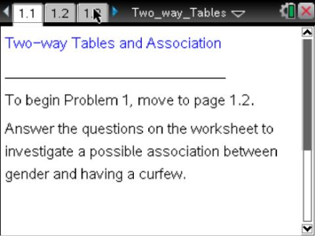  Tech Tips:  - This activity includes class captures taken from the TI-Nspire CX handheld. It is also appropriate for use with the TI-Nspire family of products including TI-Nspire software and TI-Nspire App. Slight variations to these directions may be required if using other technologies besides the handheld.  - Watch for additional Tech Tips throughout the activity for the specific technology you are using.  - Access free tutorials at http://education.ti.com/  calculators/pd/US/Online-Learning/Tutorials  Lesson Files:  Student Activity  - Two_Way_Tables_and_  Association_Student.pdf  - Two_Way_Tables_and_  Association_Student.doc  TI-Nspire document  - Two_Way_Tables_and_  Association.tns
Discussion Points and Possible Answers

Move to page 1.2.  1. The responses from the 100 students are summarized in a two-way frequency table on Page 1.2.  a. Why do you think these 100 students would be a good sample to study?  Sample Answers: The process described gave each student in the school an equal chance of being selected. This represents a random sample. | 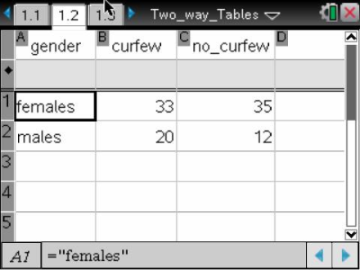
Teacher Tip: Discuss with students that random samples are more likely to generate representative samples than biased samples. This investigation is exploring the possible outcomes from a random sample.

b. How many males were selected in the sample? How many females were selected? How would you explain the difference in the number of males and females?

Sample Answers: There were 32 males selected and 68 females. The results could be due to chance. Another possible suggestion is that this school has more females than males in the total population.

2. How many of the 100 students sampled had a curfew?

Sample Answers: The data indicate that 53 students sampled had a curfew.

3. Look at the data in the table, and answer the questions below.
a. What percent of the males had a curfew?

Sample Answers: 20 out of 32 males indicated they had a curfew; therefore, 62.5% of the males indicated they had a curfew.

b. What percent of the females had a curfew?

Sample Answers: 33 out of 68 females had a curfew; therefore, approximately 48.5% of the females indicated they had a curfew.
c. Do you think it is accurate to conclude that males at Rufus King are more likely to have a curfew than females? Explain your answer.

Sample Answers: Some students will conclude it is more likely females have a curfew as the data from the sample indicate most of the students with a curfew were females. Other students will conclude it is more likely males have a curfew as a greater percent of the males have a curfew compared to the percent of females who have a curfew. A conclusion at this point is still not clear and is the focus of the remaining questions.

Teacher Tip: Discuss with students that summaries of the sample and the total population of the school might not be the same. At this point in the investigation, the sample indicates that a greater percent of the males have a curfew than females. It is still not clear, however, as to whether or not the percent of male students from the school population are more likely to have a curfew. This uncertainty is expected and is addressed in the questions that follow. This investigation guides students into ultimately deciding whether or not a curfew is more likely if you know the gender of the student. If the selection of a male student at Rufus King is more likely to indicate he has a curfew, then an association between gender and curfew is considered possible.

4. Suppose that approximately the same percent of females as males had a curfew at Rufus King. If our sample had shown that an approximately equal percent of each gender had a curfew, how many females and how many males would have a curfew?

Sample Answers: If 36 females had a curfew and 17 males had a curfew, then approximately 53% of each gender would have a curfew.

Move to page 1.3.  5. Use the graph to answer the following questions.  a. What do you observe from the graph about the difference between females and males with curfews?  Sample Answers: The graph indicates that more females have a curfew than males have a curfew; however, it also indicates that fewer females have a curfew than do not have a curfew. The reverse is indicated for males, or more males have a curfew than do not have a curfew. | 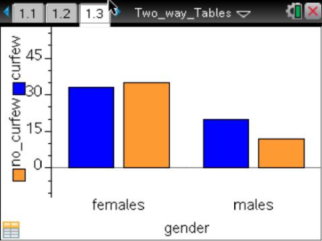
b. How would the graph look if the percent of males and females with a curfew were approximately the same? Develop a sketch of a graph that would show about the same percentages for males and females with curfews.

Sample Answers: The bar for females with a curfew would be nearly the same as the bar representing females without a curfew. Similarly, the bar for males with a curfew would be nearly the same length as the bar representing males without a curfew. Approximately half of each gender has a curfew and half of each gender does not have a curfew.

6. Move the cursor over the bars of the graph, and answer the following questions:
a. What percent of the males indicated they have a curfew?

Sample Answers: Twenty males had a curfew, or, 20/32 = 0.625. Therefore, the percent of males with a curfew is 62.5%.

b. What percent of the females indicated they have a curfew?

Sample Answers: 33 females had a curfew, or 33/68 or .485. Therefore, approximately 48.5% of the females had a curfew.

Tech Tip: Tap a column to view its numerical summary.

7. A student was identified from Rufus King. This student might or might not have completed the survey.
a. Do you think this student has a curfew? Explain.

Sample Answers: 53% of the students from the sample have a curfew. If 53% of students in the total population had a curfew, you would expect that a student selected from the total population would have a curfew as slightly more than half of the students have a curfew.

b. If the student selected in question 7a is a male, do you think this student has a curfew? Explain.

Sample Answers: Students will probably indicate yes to this question. The greater percentage of males in the sample with a curfew suggests to students that a curfew is more likely with males, and that at this point, students think an association of males with curfew is possible in the total population.

Teacher Tip: The Common Core State Standards specifically indicate: “Students should summarize categorical data for two categories in two-way frequency tables. Interpret relative frequencies in the context of the data (including joint, marginal, and conditional relative frequencies). Recognize possible associations and trends in the data.” The following questions address these standards based on the data and tables established in this investigation.

Move to page 2.1.  A Rufus King student is selected. This student might or might not have completed our survey. Would our estimate of whether or not this student has a curfew depend on the gender of this student? The answer to this question indicates whether or not there is an association between the gender of a Rufus King student and having a curfew.  8. Page 2.1 contains two tables. | 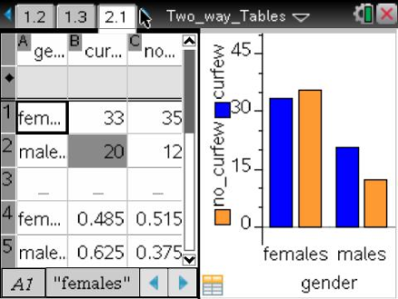
- Rows 1 and 2 make up the first table—a frequency table—and give a breakdown of the number of males or females who have a curfew along with the number of males or females who do not have a curfew.
- Rows 4 and 5 are a conditional probability table. Row 4 shows the probabilities that a female has a curfew or does not have a curfew. Row 5 shows the probabilities that a male has a curfew or does not have a curfew.
a. Note the 20 in the shaded cell of the frequency table. What does it represent?

Sample Answers: The 20 would represent 20 males with a curfew.

b. What does the cell with the value 0.625 represent in the conditional probability table?

Sample Answers: The cell with the value 0.625 represents the decimal value when the number of males with a curfew (20) is divided by the total number of males (32). This indicates that the probability of a male with a curfew from the sample is 62.5%.

c. What does the value of 0.515 represent in the conditional probability table?

Sample Answers: The cell with the value 0.515 represents the decimal value when the number of females who do not have a curfew (35) is divided by the total number of females (68). This value indicates that the probability of a female with no curfew from the sample is approximately 51.5%.

9. Enter a 5 into the shaded cell (replacing 20). Assume that 32 of the 100 students are male and 53 of the students have a curfew.
a. What does the 5 indicate?

Tech Tip: To add or modify the data in a spreadsheet cell, double-tap the cell.

Sample Answers: The 5 would represent 5 males with a curfew.

b. What is the relative frequency of males with a curfew?

Sample Answers: The relative frequency of males with a curfew is 0.156, or 15.6%.

c. What is the number of females with a curfew?

Sample Answers: If 5 is entered in the shaded cell, then 48 of the females would have a curfew.

d. A student is selected from the sample in which 5 males out of the 32 males have a curfew. If the gender of the selected student were known, what would be your estimate of the student having a curfew?

Sample Answers: If a female were selected, students would indicate that she is likely to have a curfew as approximately 70.6% of the females in the sample have a curfew. If a male were selected, students would indicate that he is less likely to have a curfew as approximately 15.6% of the males have a curfew. Note: this can be found from the conditional probability table.

e. Do you think there is a connection or association between gender and curfew based on 5 males with a curfew in the sample in which 32 students are male and 53 students have a curfew? Explain.

Sample Answers: Yes, the difference between the conditional probabilities of males with a curfew and females with s curfew suggest that there might be an association. Specifically, if a female were selected from the sample, there would be a greater probability of her having a curfew.

10. Fill in the table below by entering the given value of ‘males with curfew’ into the shaded cell of the frequency table on your handheld spreadsheet. Assume that the total number of male students remains at 32 students, and that the total number of students with a curfew remains at 53.
a. In the table below, record the percent of the males who have a curfew, the percent of females who have a curfew, and what you can observe from the graphs.

b. Also, indicate whether you think the value would suggest an association between gender and having a curfew.

Sample Answers:

Males with curfew | Percent males with curfew | Percent females with curfew | Describe the bar graphs | Does there seem to be an association?  Explain.
5 | 15.6% | 70.6% | Very small bar representing the number of males with a curfew. | Knowing the student  gender would change your estimate of the student with a curfew. Therefore, there appears to be an association between females and curfew.
17 | 53.1% | 52.9% | Slightly more than half of each gender have a curfew. | Knowing the gender does not help you predict whether or not a student has a curfew. Therefore, there is no evidence of an association.
30 | 93.8% | 33.8% | The bars would indicate almost all of the males have a curfew. | Knowing the gender would change your estimate of the student with a curfew. Therefore, there appears to be an association between males and curfew.

11. Assume that the probability of a female having a curfew and the probability of a male having a curfew is approximately the same.
a. If a sample has 32 males, 68 females, and 53 students with a curfew, estimate the number of males who have a curfew.

Sample Answers: Based on the results, from question 10, students would estimate numbers similar to the second entry of the chart in problem 10, or 17 males. Numbers close to those estimates should also be considered. Students might choose estimates in which the number of males or the number of females is slightly more than one-half the total number of each gender.
b. Is the answer ‘20 males who had a curfew’ from our sample close to or very different from the estimates you made in part a? Explain your answer.

Sample Answers: Answers will vary. 20 males are slightly more than half of the males, so students might conclude that it is close to what was derived as their estimate if there was no association.

Teacher Tip: Develop a discussion with your students to indicate their description of an association. Recall that if the gender of a selected student indicates a different estimate of the student having a curfew, then an association or relationship exists between gender and curfew.

Tech Tip: Page 2.2 gives instructions on how to seed the random number generator on the handheld. Page 2.3 is a Calculator page for the seeding process. Ensuring that students carry out this step will prevent students from generating identical data. (Syntax: RandSeed #, where # is a number unique to each student.).

Teacher Tip: Once students have seeded their random number generators, they do not have to do it again unless they have cleared all of the memory. But it is important that this be done if the memory has been cleared or with a new device, as otherwise the "random" numbers will all be the same as those on other similarly cleared devices.

Move to page 3.1.  12. Select the arrow to draw one sample. Fifty-three (53) students are randomly selected from a sample of 100 students in which 68 students are female and 32 are male. Notice the plot displays the number of males from the 53 students selected.  a. Who do the 53 students represent in this investigation?  Sample Answers: The 53 represents students in the sample with a curfew. | 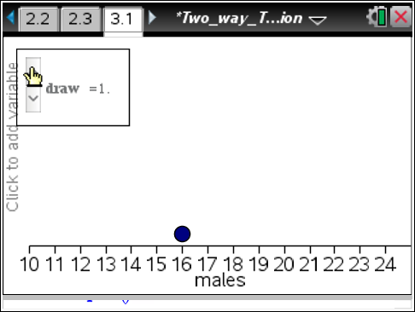
b. How many males in the sample you drew had a curfew?

Sample Answers: The number plotted on the graph represents the number of males with a curfew. In the above example, 16 males in the selection of 53 students had a curfew.

c. Complete the following frequency table based on the numbers from the sample you drew:

Sample Answers: Answers will vary based on the number obtained by the student from the program. If 16 males were obtained in the first draw, then the following answers would be derived:

 | Curfew | No curfew
Females | 37 | 31
Males | 16 | 16

d. Complete the following conditional probability table based on the numbers you obtained:

Sample Answers: The following conditional probabilities are based on 16 males:

 | Curfew | No curfew
Females | 0.544 | 0.456
Males | 0.5 | 0.5

If you select the arrow again, another sample of 53 students is randomly selected from the 100 students with the same gender break-down as before. The number of males in the sample is plotted on the graph. Continue to select the arrow. After ten selections, the number of samples drawn per selection increases to groups of ten until you reach 100 samples. Generate 100 samples, and examine the resulting dot plot.  13. Describe the dot plot of the 100 simulated samples.  Sample Answers: Although not a perfect mound shape, it is anticipated that the dot plot of the 100 samples will have a peak around 16 to 18 males. The numbers tend to drop after the peak is reached. | 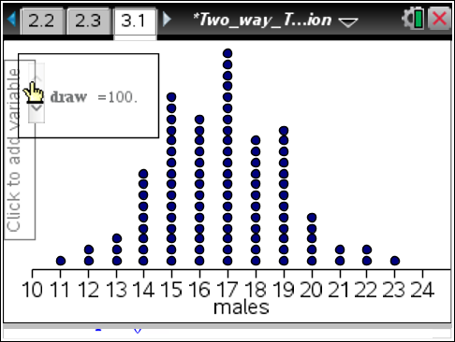
14. Assume the percentage of males with a curfew was approximately the same as the percentage of females with a curfew when each of the samples was drawn. Determine an interval from the dot plot representing the number of males with a curfew that includes approximately 95 of the 100 samples. What does this interval represent?

Sample Answers: Answers will vary based on the final dot plot obtained by the students. In the above dot plot, an interval of 13 to 22 males represents approximately 95 of the selections. This interval indicates that 95% of the time you would expect between 13 and 22 males to have a curfew.

Teacher Tip: This is a good place to have students share their plots and intervals. Discuss the similarities and differences in the plots. Consider asking the students what would happen if 1000 samples were taken? Where would you expect 95% of the samples to fall? Would we still have the same interval?

15. Based on your interval found in Question 14, are the 20 male students with a curfew observed in our original sample inside or outside this new interval? Explain what it means if 20 is within the interval. Also, explain what it means if 20 is outside the interval.

Sample Answers: 20 males is a number that would be included in most intervals generated by the simulation; this would indicate that obtaining a sample of 20 males with a curfew is possible even if there is little difference in males and females having a curfew. If 20 was outside the interval summarized in question 14, then there would be evidence that obtaining 20 is unlikely if there was no association between gender and the curfew question. This would indicate the observed sample is not expected and that a possible association between gender and curfew would explain the result. Since our initial sample was randomly generated, it is highly unlikely we got an unusual sample (but not impossible).

16. Do the 20 males with a curfew described in the opening sample give a strong indication that males are more likely to have a curfew than females? Explain.

Sample Answers: No, the 20 males represent a value that could result if the occurrence of curfew is approximately the same for males and females. This result does not provide a strong indication that males are more likely to have a curfew.

Wrap Up
Upon completion of the lesson, the teacher should ensure that students are able to understand:
  - How to interpret the cells of a two-way frequency table.
  - How to interpret the conditional probabilities summarized in a two-way table and its graph.
  - How to estimate values that would indicate no association between the two variables summarized in the frequency table and the conditional probability table.
  - How to interpret whether or not the observed results from a sample indicate the likelihood of an association based on a simulation.
  - How to interpret whether or not there is an association between two variables based on the differences displayed by their graphs.

Assessment

Which of the following headlines for the school website is more accurate? Explain your selection.

“Males students at Rufus King are more likely to have a curfew”

“Curfew for Males and Females is about the same”

Sample Answers: Based on the results of the activity, the headline “Curfew for Males and Females is about the same” is more accurate as there is not enough evidence to support an association of curfew and gender.

This activity is based on the ideas discussed in Richard Scheaffer and Josh Tabor’s article “Statistics in the High School Mathematics Curriculum - Building Sound Reasoning under Uncertain Conditions,” Mathematics Teacher: August 2008, Volume 102, No. 1.

